*Suggesting the minimum support requirements at tourist destination, community level to ensure suitability of setting up of homestay ecosystem*

# A Minor Project Synopsis Submitted to



**Rajiv Gandhi Proudyogiki Vishwavidyalaya, Bhopal Towards Partial Fulfillment for the Award of**

# Bachelor of Technology (Computer Science and Engineering)

### Under the Supervision of Prof. Mahendra Verma

**Submitted By Arjav Sethi(0827CS201043) Atharv Gour(0827CS201046) Bhushan Kokate(0827CS201061) Devesh Ujonia (0827CS201069)**



**Department of Computer Science and Engineering Acropolis Institute of Technology & Research, Indore July-Dec 2022**

### Abstract

Finding the bare minimal prerequisites for establishing a homestay ecosystem for the tourism business which must be consistent with environmentally and socially responsible tourist practises.

### Introduction of the Project

Homestay tourism is common in many regions and enriches the visitor's experience with real sociocultural diversity. Homestays are a suitable alternative tourism offering for a city with a wealth of natural attractions in remote communities.

Moreover, homestay hosting is advantageous to host families because that provides social connection, the preservation of local culture, a sense of local pride, income and work, and educational opportunities for operators' children including enhancing their language skills. Even if it sounds and looks fantastic, it can be expensive to set up a homestay that meets standards. To draw large numbers of tourists, a lot of factors, including investment capital and government support for marketing initiatives, are essential. Hence, it is important to recognize the necessities for establishing homestay ecosystems so that the government may understand about them and encourage the locals in creating them. To make homestay tourism an actuality, an innovative planning is intended with the foregoing concerns in mind. There are a number of ways to approach this However, the opportunities are endless, so there's plenty more to explore.

### Objective

Planning and development of tourism should not take place in isolation , it is about working together. This involves formal partnerships as well as strengthening and utilizing local democratic structures . A long-term view encouraged, with resources committed accordingly where possible, actions should be self-sustaining. Finance must take account of how initiatives, once started, can be maintained into the future. This means influencing the volume and nature of tourism demand, the choices made by tourists such as products selected and mode of travel , their activities and behaviour . It should be increasingly accepted that a quality tourism destination or product is one that addresses the full range of sustainability issues rather than simply concentrating on visitor satisfaction.

### Scope

Home Stay refers to reserving accommodation at someone's home outside of his or her neighbourhood, allowing the traveler to experience a new lifestyle, unique customs, or even language. However, the concept of homestay varies depending on the circumstances of the countries involved, for instance, the concept of homestays in western countries intended to provide an ideal setting for overseas students to become acquainted with the target culture and language while remaining in the comfort and safety of a family while in eastern countries

homestays generally resembles leisure activities, adventure and exploring indigenous custom like New Zealand has Farmstay, Cottage homestay , Singapore has Urban homestay.

1. **Study of Existing System**

## AUSTRALIA

1. Problems Addressed –
   1. Infrastructure development. b)energy and waste minimization.
2. Advantages – The strategy together with these grants strengthened established collaborative networks and a sophisticated ecotourism industry that continues to position Australia as one of the world’s leading ecotourism providers.
3. Disadvantages – a)Intense use of resources.

b)Increased waste, pollution and emissions.

1. Gaps Identified –
   1. Effective political and technical structures. b)The Tourism in Protected Areas Initiative.
2. Reference link- https://[www.tourism.australia.com/content/dam/assets/document/1/6/w/u/x/200213](http://www.tourism.australia.com/content/dam/assets/document/1/6/w/u/x/200213) 7.pdf

https://[www.australia.com/en-in](http://www.australia.com/en-in)

## GHANA

1. Problems Addressed –
   1. visa acquisition and air transportation to Ghana.
   2. general lack of understanding of the African American market. 2)Advantages –

a)Poverty alleviation, including distribution of benefits within the community. b)Conservation of natural and cultural heritage resources, through the efforts of the

community supported by visitor income. 3)Disadvantages –

a)Environmental Damage. b)Exploitation Of Culture.

1. Gaps Identified –
   1. Data collection and dissemination.
   2. Community consultation ,Project assessment against feasibility and sustainability criteria.
2. Reference link - https://visitghana.com/ https://[www.bog.gov.gh/wp-content/uploads/2019/07/tourism.pdf](http://www.bog.gov.gh/wp-content/uploads/2019/07/tourism.pdf)

## MEXICO

1. Problems Addressed –
   1. challenging economic conditions in key source markets. b)natural disasters, health scares and security concerns.
2. Advantages –
   1. Developing incentives for sustainable tourism activities. b)Establishing ecotourism in protected natural areas.
3. Disadvantages –
   1. Environmental impact and Socio-economic impact. b)Urban development in uneven areas.
4. Gaps Identified -
   1. simplifying and rolling out the sustainable tourism indicator system. b)strengthening the involvement of federal organizations in the overall initiative.
5. Reference link – https://[www.visitmexico.com/en/](http://www.visitmexico.com/en/)

<http://www-2.rotman.utoronto.ca/mpi/wp-content/uploads/2015/04/2015-MPIWP-> 002_Tourism-in-Mexico_Massam-Hracs-Espinoza.pdf

## KAIKOURA , NEW ZEALAND

1. Problems Addressed –
   1. The threat of a diminishing visitor experience and income.
   2. Local concern for the environment and Reaching capacity in accommodating waste.
2. Advantages –
   1. Tree planting—CO2 offsetting. b)Biodiversity, land and coastal management.
3. Disadvantages –
   1. water contamination and loss of mana.
   2. abuse of cultural values.
4. Gaps Identified - Energy efficiency initiatives.
5. Reference link - https://[www.kaikoura.co.nz/](http://www.kaikoura.co.nz/) https://core.ac.uk/download/pdf/35458302.pdf

## COSTA RICA

1. Problems Addressed -
   1. problems with in the habitats of animals and plants. b)polluting oceans and deforestation in rainforest.
2. Advantages –
   1. The economy becomes stronger and more stable.
   2. Jobs open up for people and higher standard of living. 3)Disadvantages –
3. The country relies too much on the income of tourism.
4. Tourists take resources away from locals. 4)Gaps Identified –

a)Ecotourism and market awareness. b)Tourism strategy and planning.

5)Reference link -https://[www.visitcostarica.com/en](http://www.visitcostarica.com/en)

https://[www.cbd.int/doc/nbsap/tourism/CostaRica(Tourism).pdf](http://www.cbd.int/doc/nbsap/tourism/CostaRica(Tourism).pdf)

### Project Description

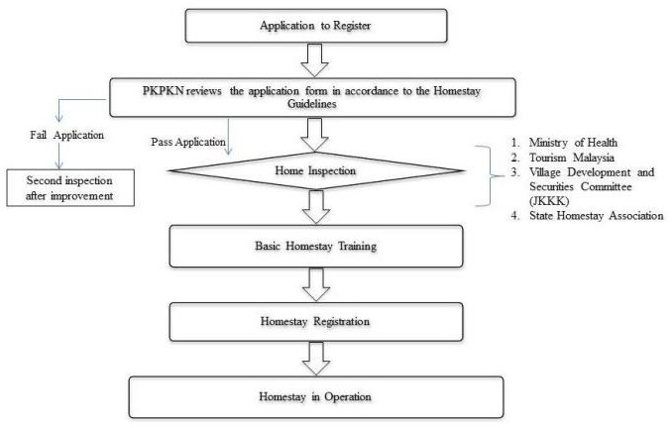

Flowchart of Homestay Registration Process

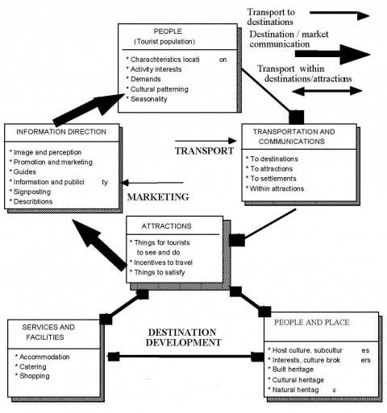

**The Tourism Environment System**

### Methodology/Planning of the Project work -

Methodology includes the steps to be followed to achieve the objective of the project during the project development.

For this there are preferably 3 steps-

1) Research design, sampling methods and data collection technique –

Both national and international tourists are the respondent of the present study. Darjeeling Himalaya's sustainable homestay tourism was chosen for its potentiality to attract a large number of tourists, provide a diverse range of attractive places, and provide opportunities to participate in tourism for an extended period.

The present study's methodology included a Delphi technique survey.

The current research was divided into two parts in 1st; the Delphi technique was used to select significant variables for assessing sustainable homestay tourism and tourist satisfaction and in the second part, it was used to determine the most relevant variables for assessing the sustainable homestay tourism and tourist satisfaction.

Around 15 homestay operators with at least seven years of were selected.

Here the experts were requested to identify the most significant variables related to sustainable homestay

Finally, Tourist samples were collected using a convenient sampling approach 2) Data screening and multivariate normality analysis-

The data were reviewed and screened before being analyzed in SEM. Here, certain

missing data were discovered, which are replaced and alternated by arithmetic mean.

3) Instrument development procedure-

In order to develop the questionnaire tool, several sustainability items were gathered from previous studies, and following that; Delphi technique was used to finalized the items related to the present study and participants were interviewed accordingly.

### Expected Outcome -

Major expected outcomes are –

* 1. Developing a sustainable tourism strategy - To encourage greater adherence to the strategy and dedication to its implementation, developing a strategy for sustainable tourism should be a collaborative effort involving a variety of stakeholders.
  2. Determining the level and nature of tourism - Governments should make strategic decisions on the general level and nature of tourism that may be suitable for the nation or particular destinations as part of the strategy, in consultation with partners.

This involves setting goals for the sector's size and worth as well as its performance in relation to other sustainability-related variables. Decisions on this will be influenced by a number of variables, such as the overall strategic

objectives and other variables found in the scenario analysis, such as present levels of tourism, market trends, and various resource constraints.

* 1. Influencing tourism development - Development of tourism can be influenced when policies are agreed and plans are made for tourism in an area, and by determining the nature and shape of individual development proposals, and deciding whether or not they should happen.
  2. Influencing the operation of tourism enterprises
  3. Influencing visitors—promoting sustainable consumption - Governments can influence visitors directly in a variety of ways, including via marketing and information activities, and indirectly through the effect of their policies on the travel trade.

### Resources and Limitations -

Resources –

1. General information on sustainable development: impacts and principles
2. Sustainable development of tourism: principles, policies and guidelines
3. Structures and strategies to work with other stakeholders
4. Measurement instruments
5. Command and control instruments
6. Economic instruments
7. Voluntary instruments
8. Supporting instruments Limitations-

Tourism, like others sectors, faces major global challenges. Five of them are-

* 1. Managing dynamic growth -
  2. Climate change - Climate change is a major issue for the long term sustainability of tourism in two senses: climate change will have consequences for tourism, and tourism is a contributor to climate change.
  3. Poverty alleviation - All countries need to ensure that people employed in tourism are properly remunerated, receive proper treatment and are given opportunities for advancement.
  4. Support for conservation - The need to find more financial resources to support conservation is a worldwide issue, although the severity of the problem varies from country to country.
  5. Health, safety and security - In recent years, uncertainty about the health and safety of travel and of certain destinations has caused significant fluctuations in tourism flows.

1. **Conclusion -** Since there is a direct relationship between sustainability and tourist satisfaction, it is impossible to accomplish sustainability in tourism without it.

There is a higher need for action as evidenced by the need to enhance tourists' experiences, enhance public-private sector collaboration, and provide more precise plans and land-use rules.

The administration of tourism should contribute to ensuring the local economy's economic viability. If it is not made available to everyone, tourists might not be pleased. People should upgrade their employment facilities in a sustainable fashion in order to increase employment quality, economic viability, and local prosperity. In order to supply it, there must be demand-driven handcraft production, employment development in the tourism industry, and market connections.

Emphasis should be placed more heavily on visitor duration of stay and new destination development. Understanding how environmental sustainability affects overall visitor pleasure with nature-based tourism is still essential, even though it turns out that environmental sustainability has no discernible impact on visitor contentment.

### References

[**https://core.ac.uk/download/pdf/148367225.pdf**](https://core.ac.uk/download/pdf/148367225.pdf)[**https://journals.openedition.org/belgeo/12406**](https://journals.openedition.org/belgeo/12406)[**https://www.sciencedirect.com/science/article/pii/S2666049021000748**](https://www.sciencedirect.com/science/article/pii/S2666049021000748) **https://wedocs.unep.org/bitstream/handle/20.500.11822/8741/- Making%20Tourism%20More%20Sustainable_%20A%20Guide%20for%20Policy%20M akers-2005445.pdf?sequence=3&isAllowed=y**